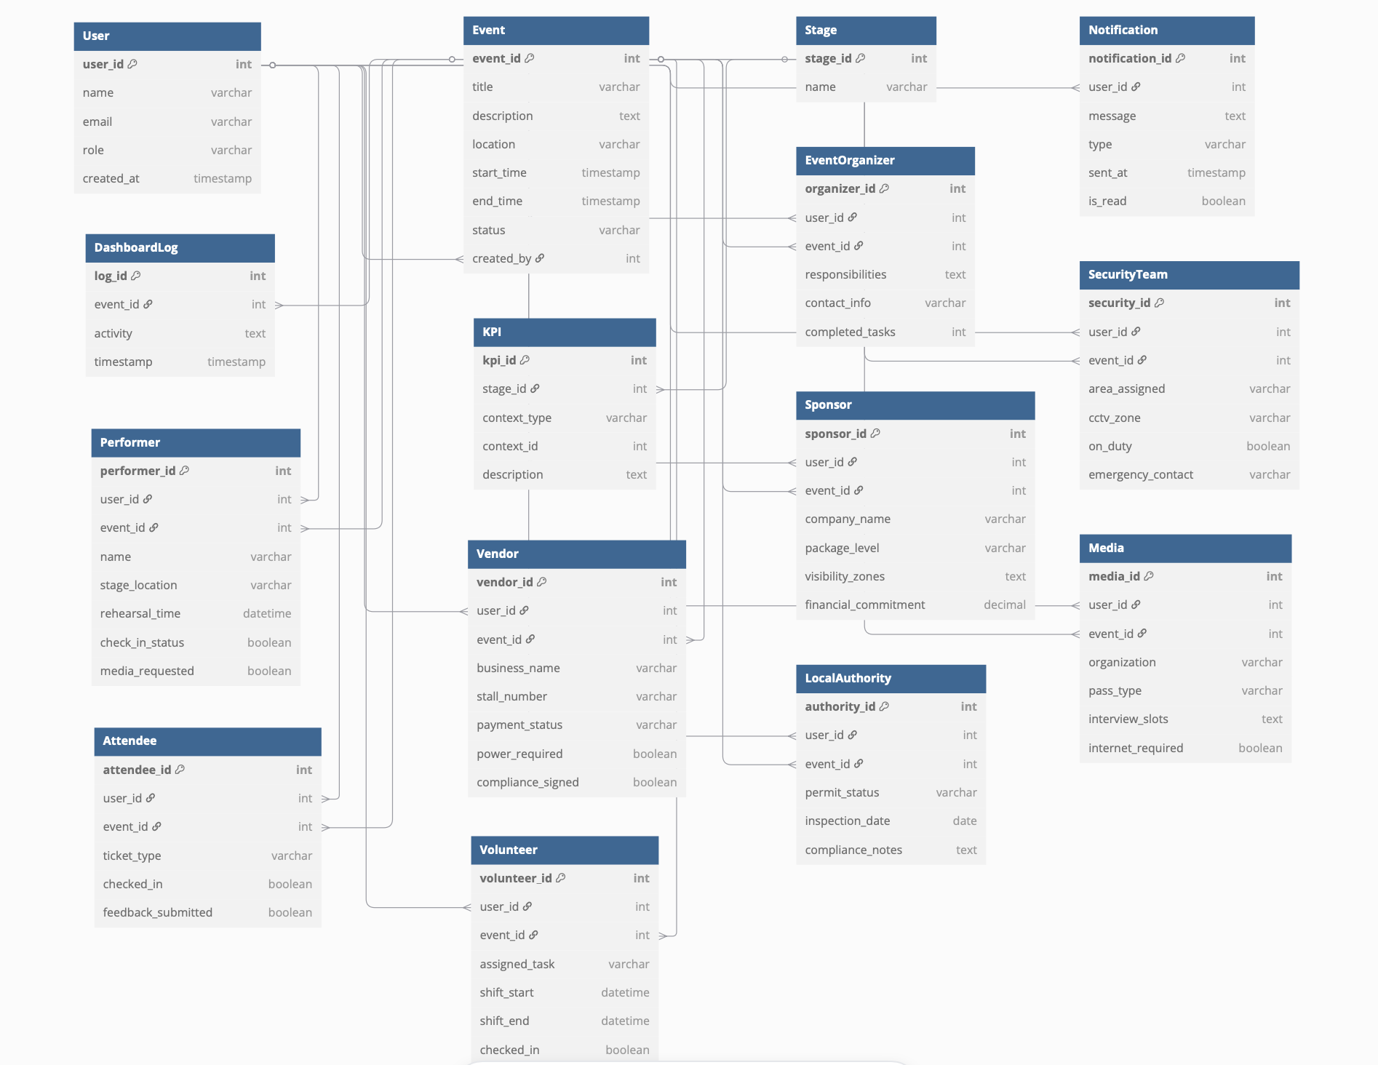

### **Core Entities**

|  |  |  |
| --- | --- | --- |
| **Table** | **Primary Key** | **Relationships** |
| User | user_id | Connected to all persona tables via user_id |
| Event | event_id | Linked to all persona tables via event_id |
| Stage | stage_id | Used in KPI to track the event phase |
| Notification | notification_id | Linked to user_id |
| Checkin | checkin_id | Links user_id to event_id |
| Feedback | feedback_id | Links user_id to event_id |
| DashboardLog | log_id | Logs event-specific activities |

### **KPI Tracking Table**

|  |  |  |  |
| --- | --- | --- | --- |
| **Table** | **Primary Key** | **Foreign Keys** | **Notes** |
| KPI | kpi_id | stage_id, context_type, context_id | Links a performance metric to any persona/entity |
| Stage | stage_id | - | Phases like "Pre-Event", "On-Event Day", etc. |

### **Persona Tables**

Each links to both User (who they are) and Event (what they’re part of):

|  |  |  |
| --- | --- | --- |
| **Persona Table** | **Primary Key** | **Foreign Keys** |
| EventOrganizer | organizer_id | user_id, event_id |
| SecurityTeam | security_id | user_id, event_id |
| Performer | performer_id | user_id, event_id |
| Vendor | vendor_id | user_id, event_id |
| Sponsor | sponsor_id | user_id, event_id |
| Media | media_id | user_id, event_id |
| Attendee | attendee_id | user_id, event_id |
| Volunteer | volunteer_id | user_id, event_id |
| LocalAuthority | authority_id | user_id, event_id |

## **Relationships**

* One Event has many Performers, Vendors, etc.
* One Performer belongs to one Event and one User
* One KPI is tied to a Stage and a persona record (via polymorphic relationship)

|  |  |  |  |
| --- | --- | --- | --- |
| **Parent Table** | **Child Table** | **Relationship Type** | **Join Key** |
| User | Event | One-to-Many | created_by |
| User | EventOrganizer | One-to-Many | user_id |
| User | Performer | One-to-Many | user_id |
| User | Attendee | One-to-Many | user_id |
| User | Vendor | One-to-Many | user_id |
| User | Volunteer | One-to-Many | user_id |
| User | Sponsor | One-to-Many | user_id |
| User | Media | One-to-Many | user_id |
| User | SecurityTeam | One-to-Many | user_id |
| User | LocalAuthority | One-to-Many | user_id |
| User | Notification | One-to-Many | user_id |
| Event | [All Personas] | One-to-Many | event_id |
| Event | DashboardLog | One-to-Many | event_id |
| Stage | KPI | One-to-Many | stage_id |